

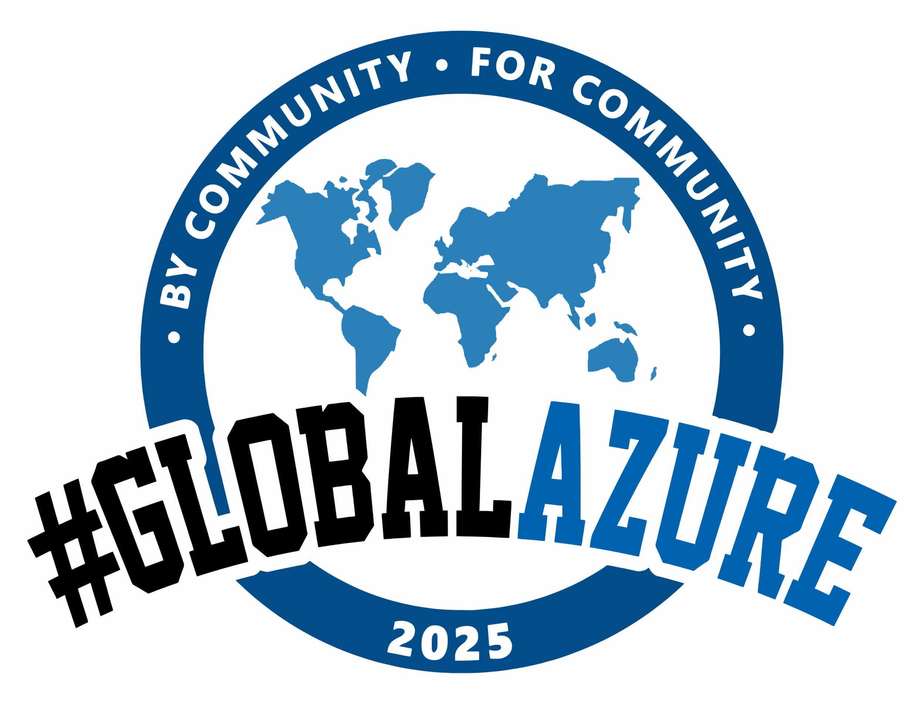

Melbourne 2025   
Sponsor Pack

# Introduction – Global Azure Bootcamp

Since the very first Global Azure Bootcamp, organised over ten years ago, what is now known as Global Azure has gone from strength to strength. Three days where enthusiasts, professionals, students and community leaders around the world come together to share their knowledge, experience, and passion for the Microsoft Azure cloud.

We are excited to announce that the ***Melbourne Global Azure 2025*** will take place ***Saturday 10th of May!*** You can also be part of the largest global community event for Azure technology on the planet!

Global Azure 2024 by the numbers was impressive: ***483 speakers*** delivered ***445 sessions*** at 110 events organised by ***105 communities.*** Thousands of people in the Azure community around the globe joined either in person or online.

During the bootcamp, Microsoft & GitHub product group members, partner evangelists, MVP’s and real-world customers explore the latest Microsoft technologies in a single day. This sponsorship package aims to inform IT vendors on the possibilities the Bootcamp offers for showcasing your services and solutions to visitors during this event.

“There is no better way to learn about Azure than from the community of Azure enthusiasts at the Global Azure event.” **Scott Guthrie**



**EVP Cloud and AI, Microsoft**

# Azure Bootcamp 2025 in figures

The 2025 Melbourne edition of the Global Azure Bootcamp will take place on May 10th at a venue yet to be selected. To have an idea of what the event entails, below you will find a summary of the event.

|  |  |  |  |
| --- | --- | --- | --- |
| Cycle with people outline  4,600+ members with one local community | Route (Two Pins With A Path) outline  3 tracks & more than 20 breakout-sessions | Star outline  20+ experts/Microsoft Most Valuable Professionals | Group of men outline  250+ attendees |
| Internet outline  20,000+ online impressions | Online Network outline  72hours + of #GlobalAzure trending topic on X | Handshake outline  Lead generation at the event |  |

**View Here:**

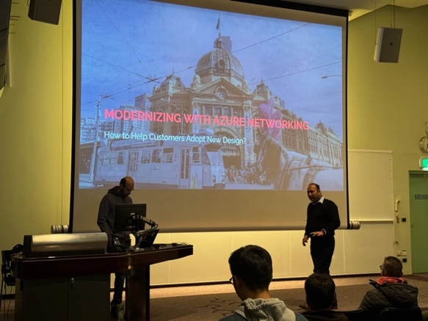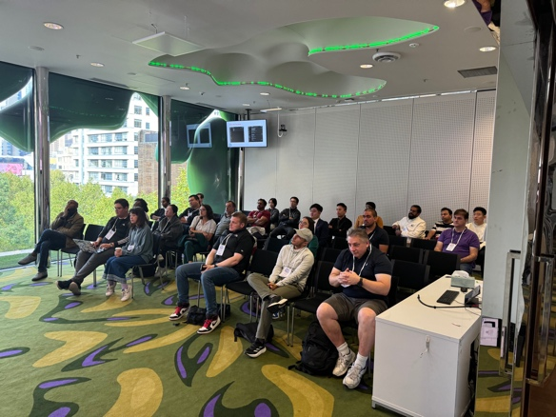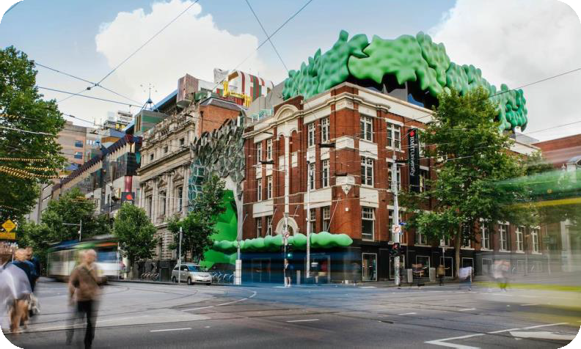Website (Local): [https://melbourneazurebootcamp.com](https://melbourneazurebootcamp.com/) Website (Global): [https://globalazure.net](https://globalazure.net/)

# Melbourne 2025 Agenda

Planning for the event is already well underway, our 2025 Call for Speakers (CFS) opened on January 1st, with our 2024 CFS receiving over 50 submissions from local, national, and international participants. We expect similar participation this year.

Our current program* is as follows.

|  |  |  |  |
| --- | --- | --- | --- |
| **Time** | **Main Area** | **Room 1** | **Room 2** |

8:30am Check-in & Arrival

|  |  |  |  |
| --- | --- | --- | --- |
| 9:00am |  | Event Welcome |  |
| 9:30am | Session 1 | Session 2 | Session 3 |
| 10:30am | Session 4 | Session 5 | Session 6 |
| 11:30am | Session 7 | Session 8 | Session 9 |

12:30pm Lunch

|  |  |  |  |
| --- | --- | --- | --- |
| 1:30pm | Session 10 | Session 11 | Session 12 |
| 2:30pm | Session 13 | Session 14 | Session 15 |

3:30pm Afternoon Tea

|  |  |  |  |
| --- | --- | --- | --- |
| 3:50pm | Session 16 | Session 17 | Session 18 |

4:50pm International Guest Speaker

5:30pm Q&A Panel & Event Close

6:00pm Event Finishes

* The program is subject to change based on speaker availability, scheduling and other influencing factors

# Sponsor Packages 2025

The Melbourne edition of the Global Azure is a free, non-profit event run for the benefit of the local technical community. In 2025 we are seeking sponsorship to facilitate operating costs such as Venue hire, catering and security.

The bootcamp offers three (3) sponsorship packages. This sponsorship package offers you the ability to show services and solutions to the visitors during this event. At the event square you can show your services and solutions in a relevant way. Additionally, it provides the opportunity to network and socialize with participants, speakers, partners, user groups and other interested.

|  |  |  |  |  |
| --- | --- | --- | --- | --- |
| Booth Space at the event | **Diamond (Venue)** | **Emerald** | **Platinum** | **Gold** |
| ✓ | ✓ | ✓ |  |
| 5 Minute session during introduction | ✓ |  |  |  |
| A breakout Session in Sponsor Rooms | ✓ | ✓ |  |  |
| Logo Placement on event Lanyard | ✓ |  |  |  |
| Logo Placement/Solution in slide during sessions and in online recordings | ✓ | ✓ | ✓ | ✓ |
| Logo on the Melbourne Azure Bootcamp Website | ✓ | ✓ | ✓ | ✓ |
| Listing in slides during the opening keynote | ✓ | ✓ | ✓ | ✓ |
| **Cost** | **Venue Cost** | **AUD $3000** | **AUD $2000** | **AUD $1000** |

Due to the non-profit nature of the bootcamp, sponsorship amounts may be partially refunded should the event operate under-budget.

# 

# 2024 Photo Gallery

After a physical hiatus through the Covid pandemic, the Melbourne event returned to an in-person format for 2024. This return was a massive success, with the 2024 attendance of 285 passionate enthusiasts exceeding targeted attendance of 200, generating strong interest for sponsors.

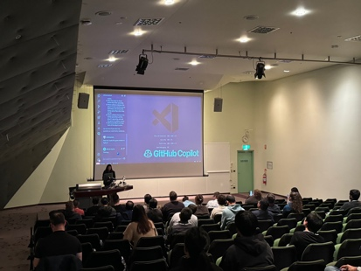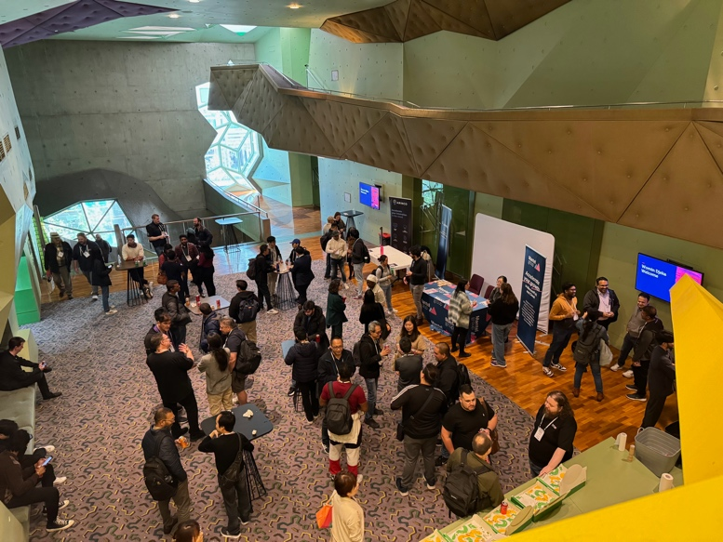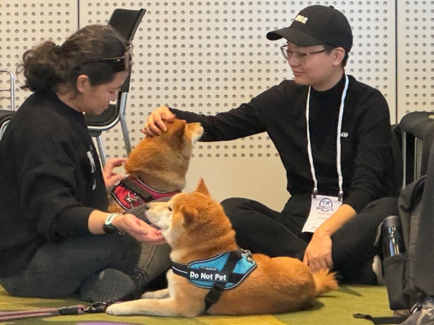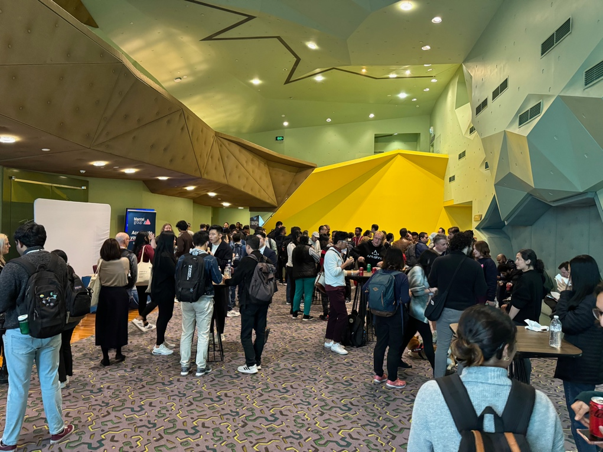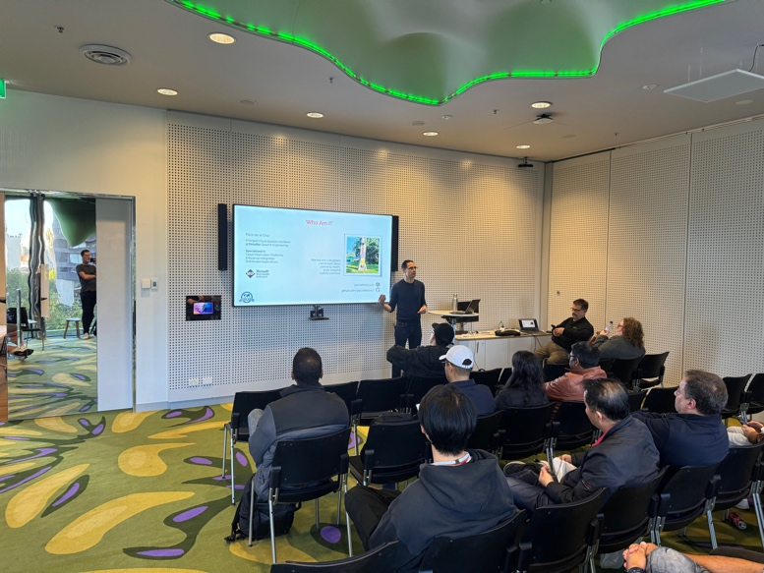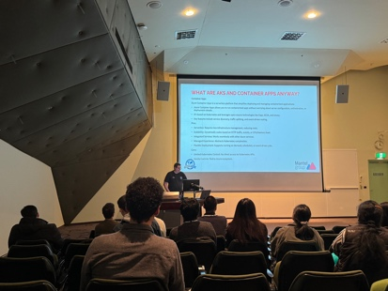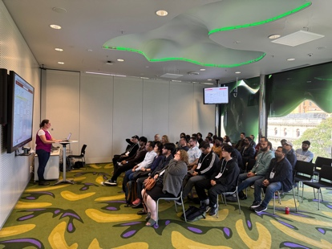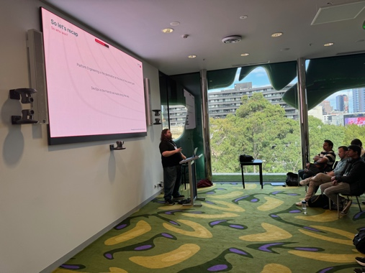

# Sponsorship Agreement

|  |
| --- |
| **Event Sponsor:** |
| **Address:** |
| **City, State, ZIP Code:** |

**Subject:** Event Sponsorship Agreement

Dear,

This agreement (the "Agreement") is made between Melbourne Azure Bootcamp ("Event Organizer") and [Event Sponsor] ("Sponsor") on this [Date] for the sponsorship of the [Event Name] (the "Event"), scheduled to take place on 10th May 2025

## Sponsorship Package:

The Sponsor agrees to sponsor the Event at the level (select the package below). The sponsorship package includes the following benefits:

|  |  |  |  |  |
| --- | --- | --- | --- | --- |
| **Global Azure 2025 Sponsorship Package** | **Diamond** | **Emerald** | **Platinum** | **Gold** |
| **Cost** | Venue Cost | AUD $3000 | AUD $2000 | AUD $1000 |
| **Package Selection** | [ ] | [ ] | [ ] | [ ] |

## Sponsorship Fee:

In consideration of the Sponsorship Package, the Sponsor agrees to pay the Event Organizer a sponsorship fee of

(AUD) no later than 20/04/2025. Payment shall be made via Bank Deposit.

## Sponsor's Obligations:

The Sponsor agrees to fulfil the following obligations:

1. Provide the Event Organizer with the Sponsor's logo and any relevant marketing materials within 2 weeks
2. after signing the agreement.
3. Cooperate with the Event Organizer regarding any promotional activities related to the Event.
4. Comply with all applicable laws and regulations while participating in the Event.

## Event Organizer's Obligations:

The Event Organizer agrees to fulfil the following obligations:

1. Display the Sponsor's logo prominently on all marketing materials, including but not limited to event website, banners, flyers, and social media promotions.
2. Acknowledge the Sponsor's contribution during the Event, such as mentioning the Sponsor's name during speeches or presentations.
3. Should the event operated under forecasted budget, provide refunds to Sponsors, calculated on a pro-rata basis, with each sponsor receiving a percentage % refund of any surplus aligned to their individual sponsorship contribution. E.g. Diamond Sponsor, Contoso’s investment makes up 40% of the total sponsorship budget. After operating costs, the event runs with a surplus of $520.00. Contoso is refunded 40% of this surplus ($208.00).
4. Melbourne Azure Bootcamp is an event about Microsoft Technologies and integrated products. Sessions and Booth must adhere to Microsoft technologies related topics, including products within Microsoft 365 and Azure or products that integrates with Azure or O365.

## Intellectual Property:

The Sponsor acknowledges that all intellectual property rights related to the Event, including but not limited to trademarks, copyrights, and patents, are the sole property of the Event Organizer. The Sponsor shall not use the Event Organizer's intellectual property without prior written consent.

## Termination:

Either party may terminate this Agreement by providing written notice to the other party. In the event of termination, the Sponsor will remain responsible for any payment obligations incurred before the termination date.

## Confidentiality:

Both parties agree to keep all confidential information obtained during the course of this Agreement confidential and not to disclose it to any third parties without prior written consent.

## Governing Law and Jurisdiction:

This Agreement shall be governed by and construed in accordance with the laws of Victoria, Australia. Any disputes arising under or in connection with this Agreement shall be subject to the exclusive jurisdiction of the courts of Victoria, Australia.

## Entire Agreement:

This Agreement constitutes the entire agreement between the parties and supersedes all prior discussions, understandings, or agreements, whether written or oral, relating to the subject matter herein.

Please indicate your acceptance of the terms and conditions outlined in this Agreement by signing and returning a copy to us no later than [Signature Deadline]. If you have any questions or require further clarification, please do not hesitate to contact us.

We look forward to a successful collaboration and an outstanding Event. Sincerely,

Azure Bootcamp Melbourne

**Accepted and agreed:**

|  |
| --- |
| **Sponsor Name :** |
| **Sponsor Title:** |
| **Date:** |

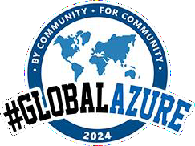





Melbourne 2025